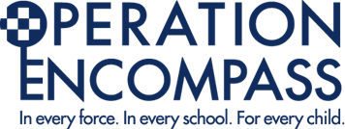

In conjunction with North Wales Police, Ysgol Cefn Meiriadog is participating in a national initiative, known as ‘Encompass’, to support children and young people who have been involved in or witness to a domestic abuse incident.
Encompass aims for a school to be alerted of a child’s exposure to domestic abuse as early as possible so to enable immediate support. This is a valuable initiative that means we can help and support our pupils and their families when they need us most.
You can find out more information on the Encompass website - https://www.operationencompass.org/

