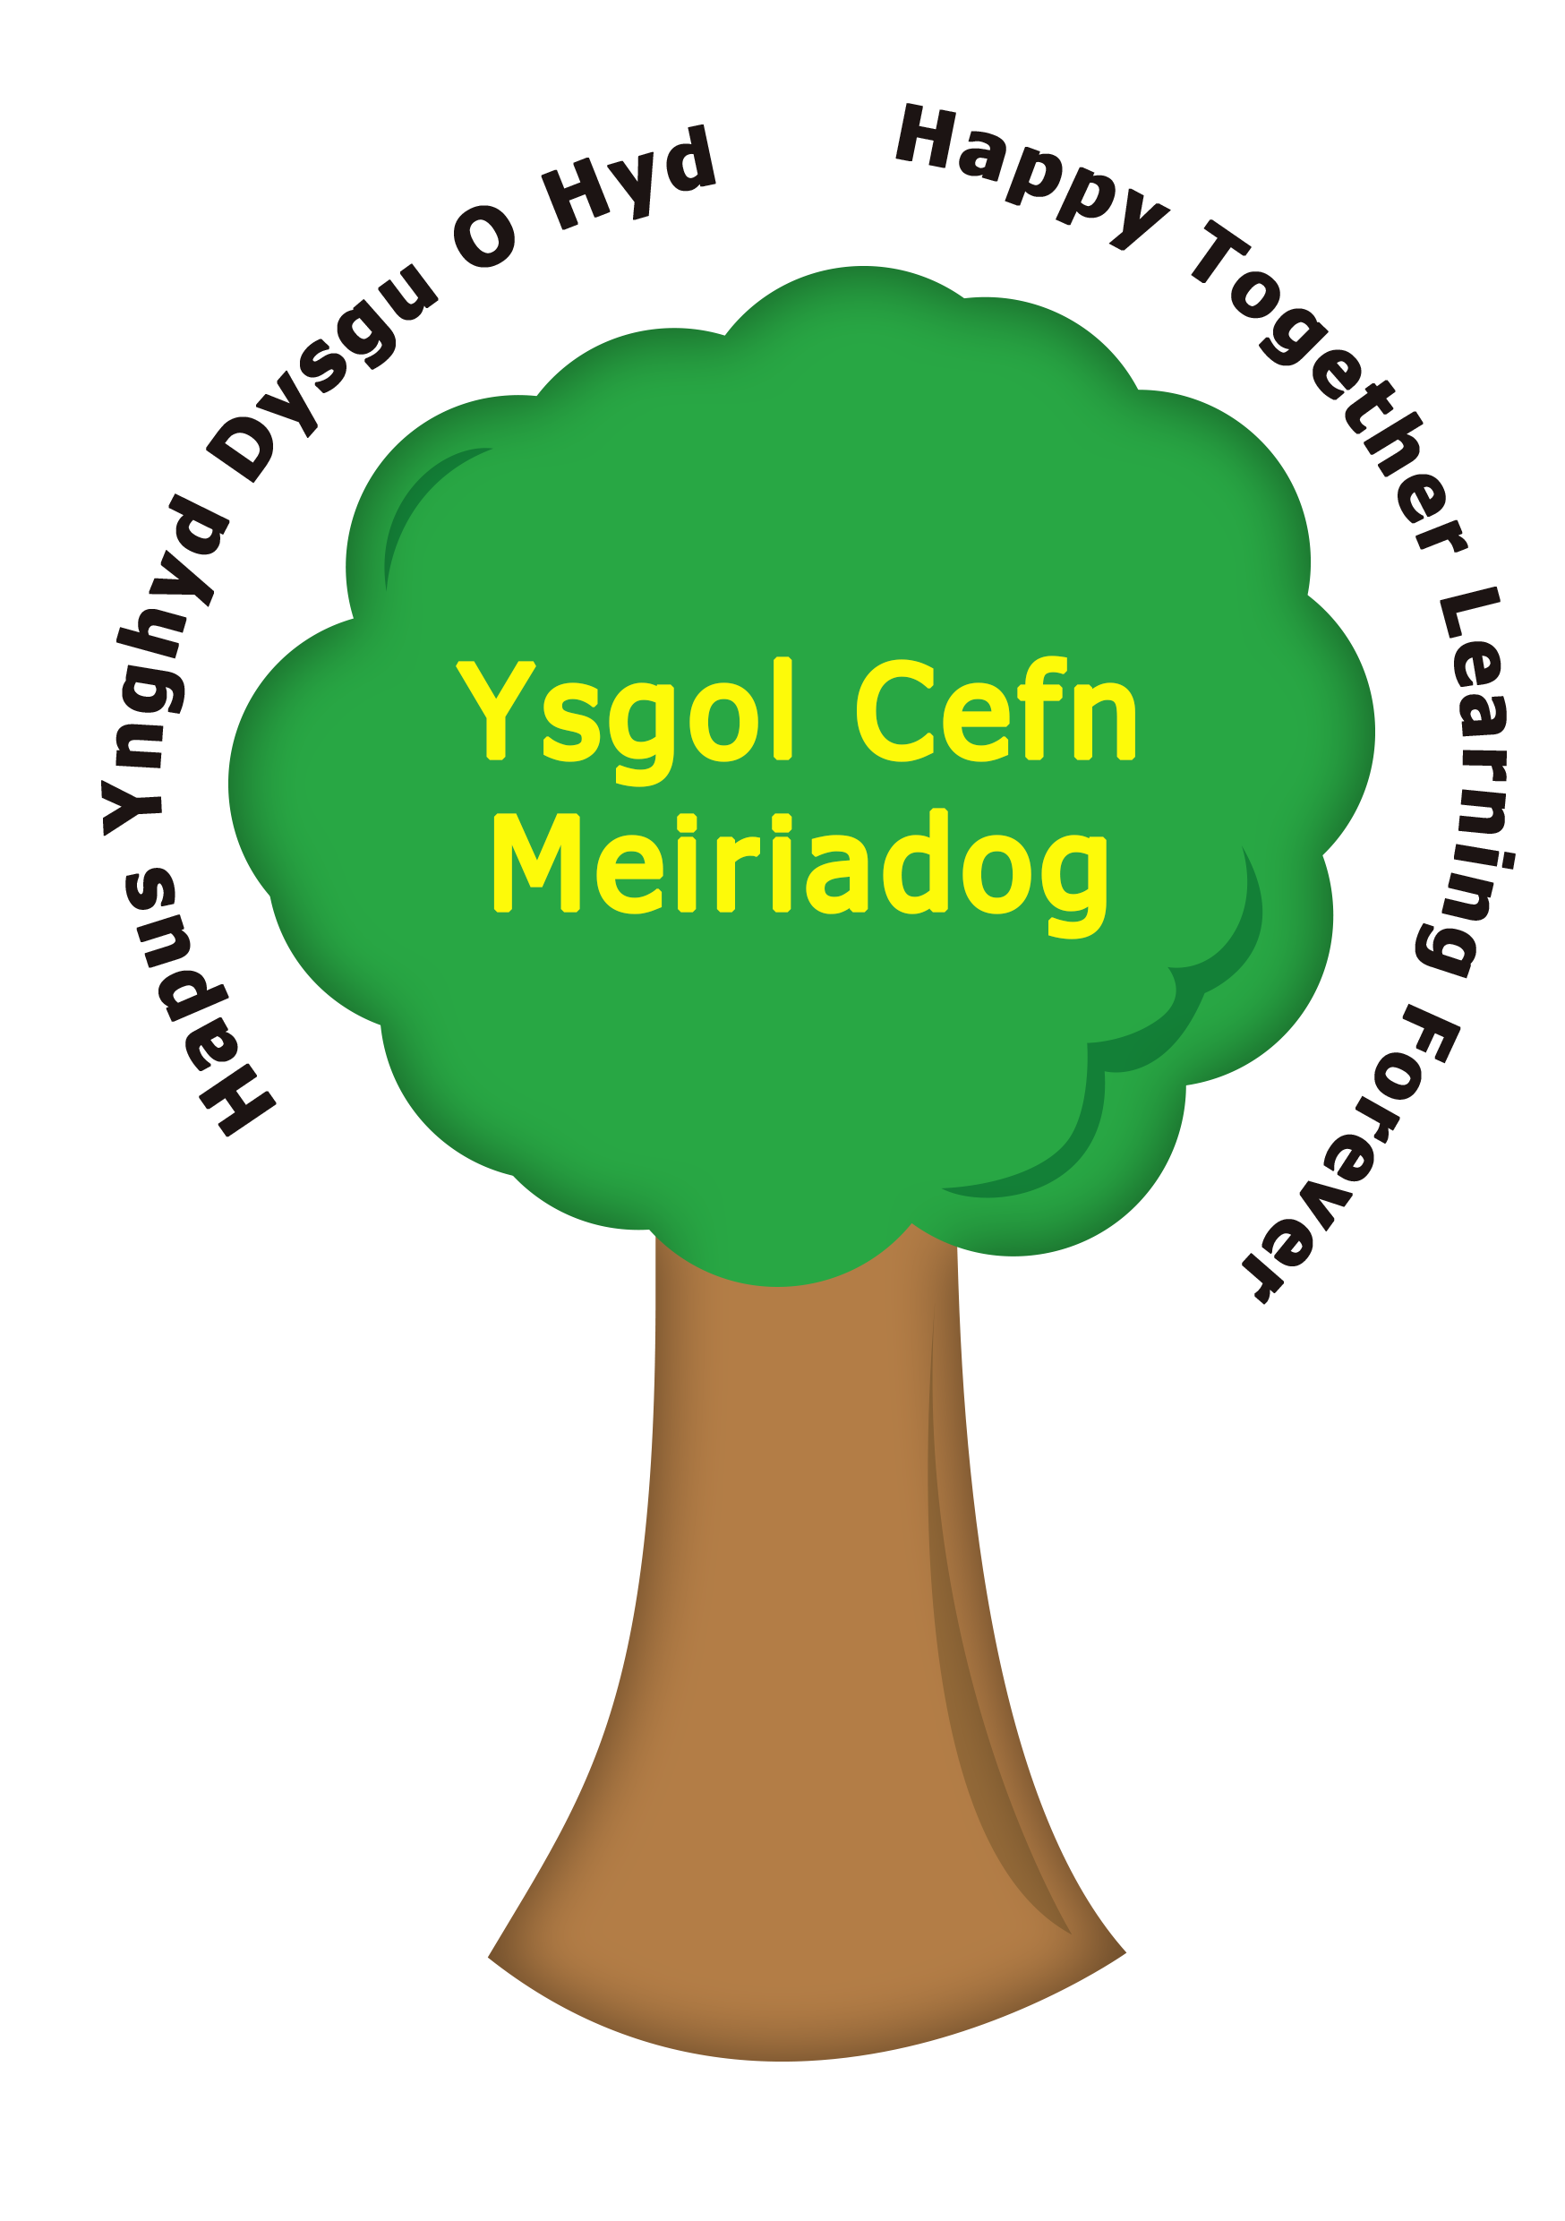
Dear Parent/Carer,

We are pleased to share with you that our school has been given the opportunity to take part in a Home Office approved project that will run jointly between schools and North Wales Police.

Encompass is a national initiative to enable information sharing between police and education in an effort to support children who have witnessed domestic abuse. Primarily, its aim is for a school to be alerted of a child’s exposure to domestic abuse as early as possible so to enable immediate support. The partnership recognises that all incidents of domestic abuse can be harmful to children and young people.

There will be two senior staff members, known as a Key Adults, trained to allow them to liaise with the police and to use the information that has been shared. They will be able to use information that has been shared with them, in confidence, to ensure that the school makes provision for possible difficulties experienced by children or their families. The Key Adults will keep this information confidential and will only share it on a need to know basis.

We are keen to offer the best support possible to all our pupils and Encompass has been nationally recognised to show that it is beneficial and supportive to all those involved. You can find out more information on the Encompass website - https://www.operationencompass.org/

Yours sincerely,

Mrs L Martin
Head Teacher

